**CS 262 – Computational Social Science**

**Fall 2019**

**Final Project Report**

**Laiba Fatima Khan**

***and***

**Syeda Fatima Hashmi**

***Present an Agent Based Model of***

**Plastic Pollution and Overfishing: Effects on Marine Life**

# *Submitted to*

**Dr. Shah Jamal Alam**



**Habib University, Karachi**

**PURPOSE**

The model is designed to simulate a simplified representation of the effect of plastic pollution and fishing practices on fish population. The model explains how microplastics and overfishing effect the fishes and therefore, can help create awareness of the problem.

**AGENTS/ ENTITIES**

We have three kinds of agents.

* ***Fishes***, one species for the sake of simplicity.
* ***Microplastics*** enter the sea from domestic waste sources: rivers, industries and beach dumping, these enter in different proportions as set by the slider.
* ***Foods*** created and scattered in sea in different proportions as set by the slider. On consumption by the fish, they replenish according to *food-replenish-rate.*
* ***Fishermen*** represent the fishing community. They are shown as a boat in the simulation, and they enter the sea periodically to get a specified amount of catch.

Agents are characterized by the following attributes:

**Energy:**Each fish is assigned an initial energy, ranging from 0 to 100 and this changes with consumption of food or plastic.

**Age:**Each fish is assigned an age initially, ranging from 0 to 10 and when it reaches **max-age**, the fish dies.

**Plastic*:*** Every fish has a count of the amount of plastic consumed, when it reaches ***max-plastic***, the fish dies

**Position:**Agents are placed randomly on the 2-D grid.

**Fish-catch:**Fishermen are assigned a certain amount of fish they need to catch by a slider ***fish-catch***.

**Color:** The fish are colored orange. Fishermen are randomly colored. Microplastics are white. Food particles are black.

**Size:** The fish have size 1. Fishermen have size 2. Microplastics have size 0.3.

Food particles have size 0.3.

**Shape:** Fish have shape “fish”. Fishermen have shape “boat top”. Microplastics have shape “triangle”. Food particles have shape “circle”

**TIME**

A tick (time step) in this model corresponds to one week.

**STATE/ GLOBAL VARIABLES**

This model has twelve global variables:

**Initial-food:** The total number of food particles in the sea at the time of initialization, implemented as a slider in NetLogo, which ranges from 0 to 500. The default value is 60.

**Number-of-initial-fish:** The total number of fish in the sea at the time of initialization, implemented as a slider in NetLogo, which ranges from 0 to 500. The default value is 130.

**Energy-from-food:** The amount of energy gained from consuming one food particle implemented as a slider in NetLogo, which ranges from 0 to 100. The default value is 10.

**Food-replenish-rate*:*** The rate at which new food particles will be created, implemented as a slider in NetLogo, which ranges from 0 to 1. The default value is 0.7.

**Max-birth-count**: The maximum amount of fish that will be reproduced by one fish, implemented as a slider in NetLogo, which ranges from 0 to 12. The default value is 5.

**Fish-catch*:*** The minimum amount of fish each fisherman aims to catch; implemented as a slider in NetLogo, which ranges from 0 to 100. The default value is 40.

**Max-age:** The age at which fish will die, implemented as a slider in NetLogo, which ranges from 52 to 520 weeks. The default value is 100. The default value is 100.

**Number-of-fishermen:** The number of fishermen (shown as boats in the model) that will catch fish, implemented as a slider in NetLogo, which ranges from 0 to 30. The default value is 5.

**Prob-river*:*** The rate at which microplastics will enter from rivers, implemented as a slider in NetLogo, which ranges from 0 to 1. The default value is 0.6.

**Prob-beach:** The rate at which microplastics will enter from plastic dumped at the beach, implemented as a slider in NetLogo, which ranges from 0 to 1. The default value is 0.2.

**Prob-industrial*:*** The rate at which microplastics will enter from industries, implemented as a slider in NetLogo, which ranges from 0 to 1. The default value is 0.6.

**Max-plastic:** This sets a threshold for the amount of plastic that fish can consume, upon crossing this, fish die. The default value is 20.

**STOP SIMULATION**

If the number of fish is equal to zero then stop the simulation.

**PROCESS OVERVIEW AND SCHEDULING**

On each tick following functions occur:

* Plastic dumping
* Move
* Eat
* Reproduce
* Aging
* Die
* Catch Fish

**SENSING**

Fishermen and Fishes can sense some other agents:

**Fishermen:** Fishermen can sense ***fishes*** within 1 patch radius and catch (kill) them.

**Fish:** Fish can sense ***microplastics*** and ***foods*** within 1 patch radius, choose one of them, move towards it and eat (kill) it.

All the agents have certain region/boundary limits so they can keep track of the patch they are placed on after each tick.

**AGENTS INTERACTIONS**

The interactions among the agents include:

* ***Fishes*** move to ***foods***
* ***Fishes*** eat ***foods***
* ***Fishes*** move to ***microplastics***
* ***Fishes*** eat ***microplastics***
* ***Fishermen*** move to ***fishes***
* ***Fishermen*** catch ***fishes***

**STOCHASTICITY/ RANDOMNESS**

The randomness in our model occurs as follows:

* ***Fishes*** are randomly placed in the water region.
* ***Fishermen*** are placed randomly along the shoreline.
* ***Microplastics*** are placed randomly around the sources when dumped by the sources.
* ***Foods*** are randomly placed in the water region.

Also,

* ***Fishes*** randomly choose one ***food*** from those within radius of 1 patch.
* ***Fishes*** randomly choose one ***microplastic*** from those within 1 patch radius.
* ***Fishermen*** randomly choose to catch from the ***fishes*** around them within a radius of 1 patch.

**SETUP/ INITIALIZATION**

The environment is divided in **Four** spatial regions:

* Beach/ Land, shown as brown.
* Shallow Sea, shown as Cyan.
* Deep Sea, shown as Dark Blue.
* Plastic Sources, shown as Red

The fishes and foods are created and placed in both Sea regions,

the microplastics are produced and dumped around the Sources, and

the fishermen are initially on the Beach.

The number of fishermen, fishes, foods, and plastic are dependent on the global variables (See Global Variables section for reference).

**INPUT DATA**

The inputs for our simulation can be taken through following global variable sliders:

* *Initial-food*
* *Number-of-initial-fish*
* *Energy-from-food*
* *Food-replenish-rate*
* *Max-birth-count*
* *Fish-catch*
* *Max-age*
* *Number-of-fishermen*
* *Prob-river*
* *Prob-beach*
* *Prob-industrial*
* *Max-plastic*

The default values and criteria on how they are set, is explained in the Global Variables section.

**OUTPUTS**

The outputs are shown through time-series plots and monitors, as visible in the following snapshot of simulation:

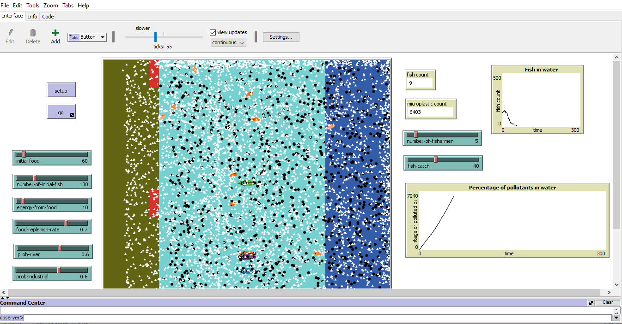

The count of fish is decreasing with time, and the amount of microplastic is increasing.

**SUB MODELS/PROCESSES**

The main processes that occur at every time step (tick) in a model run.

* **Plastic dumping*:*** Every time step (tick), plastic is created at the three sources, the quantity depending on the **prob-river**, **prob-beach** and **prob-industrial** sliders.
* **Move:** Every time step (tick), the following move:
* **Eat*:*** This depends upon the amount of plastic in the digestive system of the fish; if it exceeds 3 particles, they gain less energy from the food and eat more plastic as they are unable to differentiate between microplastics and fish food. Upon ingesting plastic, the fish lose a lot of energy.
  + If the plastic content is less, then fish gain more energy and eat more fish food than plastic.
  + ***Replenish-food:*** This gives rise to more food particles if a random number from 0 to 1 is less than**food-replenish-rate**.
* **Reproduce*:*** If the age is greater than 4 **and** energy is greater than 100 **and** plastic content is less than 10, fish hatch a certain number of offsprings as set by **max-birth-count**. Their energy is thereafter halved.
* **Aging:**Every time step (tick), age of fish increases by one week.
* **Die:**If amount of plastic in fish’s digestive system is greater than **max-plastic OR** the age is greater than **max-age OR** energy is less than or equal to 0, the fish die
* **Catch Fish:**At each tick, fishermen check for fish in radius 1, if any is found the fish die and the catch of the fishermen increases. They move in a linear direction and upon reaching the border, come back to the land. In case of not obtaining the specified **fish-catch**, go back into the sea and search for catch around them.

**REFERENCES**

* ***How Do Fish Mate?* (n.d.). Retrieved from Petful:** [**https://www.petful.com/misc/how-do-fish-mate/**](https://www.petful.com/misc/how-do-fish-mate/) **Accessed on December 6, 2019.**
* **Oliveira, M., Ribeiro, A., Hylland, K., & Guilhermino, L. (2013). Single and combined effects of microplastics and pyrene on juveniles (0+ group) of the common goby Pomatoschistus microps (Teleostei, Gobiidae). *Elsevier*, 641-647.**
* **Smith, R. R. (n.d.). *Nutritional Bioenergetics in Fish*. Retrieved from** [**http://www.fao.org/3/x5738e/x5738e03.htm**](http://www.fao.org/3/x5738e/x5738e03.htm)**. Accessed on December 6, 2019.**